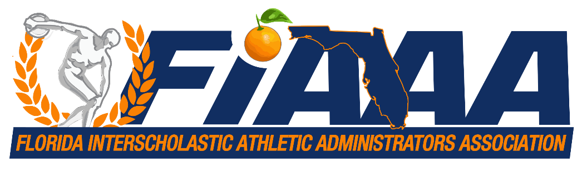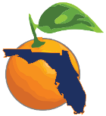­



Dear FIAAA Members, Presenters, Sponsors, and Vendors

The FIAAA has been continuously monitoring the spread of COVID – 19 and its impact on the country and the state with one key factor in mind: the health and safety of our members, meeting attendees, exhibitors, and staff who attend our state conference. **With the newest CDC update released on 3/15 and with multiple school closings throughout the state, we have decided to postpone our FIAAA conference at this time since it falls within the window of precaution.** We are still a little over six weeks away from the Conference and are working with the venue to see if any adjustments can be made to reschedule the conference this year that’s suitable for both parties.

The FIAAA will continue to monitor and communicate updates via email, our FIAAA website at fiaaa.org as well as other communication streams that will allow us to reach all our partners and stakeholders with any new information. Our hope is to have a definitive decision sent out in forthcoming weeks as we work through the process.

As we continue to hope this situation improves over the next several weeks please be sure to follow the direction and information sent out from National and State Authorities as well as updates from the Florida Department of Health and your local School Districts as they are ever changing during this time.

Protect yourself and your community from COVID-19. Wash your hands frequently with soap and water for at least 20 seconds, especially after using the restroom, before eating, and after blowing your nose, coughing or sneezing. If soap and water are not available, use an alcohol-based hand sanitizer with at least 60% alcohol. Avoid close contact with people who are sick, and stay home when you are sick.”

Here’s the link to the latest update on large events from the CDC: <https://www.cdc.gov/coronavirus/2019-ncov/community/large-events/mass-gatherings-ready-for-covid-19.html>.

The FIAAA wishes everyone good health and please stay safe during this time.